Cerebral Palsy Northamptonshire Newsletter September 2019
Reg. Charity No: 225710
Co-ordinator : Mrs Michele Walden, 36 Wickery Dene, Wootton Fields, Northampton, NN4 6BE.
Tel: 07443 562739
Email: cerebralpalsynorthamptonshire@hotmail.co.uk

Tel/text: 07443 562739

Welcome to Cerebral Palsy Northamptonshire’s September Newsletter 2019.

We aim to provide activities that our members want to do, so please let us know if there is an event or activity that you would like us to try and organise. Please ring Michele on 07443 562739 or Cam on 01604 863006 for more information. The next social committee meeting is at Michele’s on Tuesday 12th November at 9.30am at 36 Wickery Dene. All welcome.

Diary Dates:

Priscilla at Milton Keynes theatre on Wednesday 2nd October, Thursday 3rd October and Saturday 5th October . Booking closed.

Quiz/Bingo night/Fish and Chips at St Crispins Club on Friday October 11th 6.30 – 9pm

As a local charity, we need to fundraise to continue providing the social activities, grants and support that we do. Please can you ask your family and friends if they could support our bingo and quiz night, the more people that attend, the better the event.
Open to all ages, all welcome, free entry and raffle (raffle prizes greatly appreciated). No booking required, feel free to bring own nibbles if you would prefer not to order food.
Food needs ordering and paying in advance (by October 4th) and the booking form is at the end of the newsletter. Food choices are: Cod and chips £5.60, ¼ chicken and chips £4.40, ¼ pounder with cheese and chips £4.95, vegi burger and chips £4.40, chicken nuggets and dip £2.95 or just chips for £1.65.

Ring Caroline on 07931805999 for more information. £5 a book of games – don’t forget your pen/dabber.

Classic Car Motor Show at NEC Birmingham on 9th or 10th November 2019.
Open 9am – 5.30pm. Booking closes on November 2nd.

The Lancaster Insurance Classic Motor Show is the biggest and most popular classic car exhibition in the UK. With over 2500 wonderful cars from all eras, showcasing a myriad of marques and models, this really is every motoring enthusiast’s paradise!
Tickets cost £10 for disabled and carer, with additional adults costing £27.50, £17.50 for 5 – 15 year old. Under-fives go free.
Carers go free if you have proof of DLA/PIP, and a copy MUST be taken with you to the event for carers to be admitted free. Please can you note whether you have this on your form, so that we know how many paid tickets to purchase. Ring Michele on 07443 562739 to reserve your tickets and then please send completed booking form.

Iceskating at Whilton Locks on Sunday November 17th at 3pm, Whilton, Daventry, Northamptonshire. NN11 2NH

Open air and with real ice you can experience an exhilarating skate with friends and family. The real ice rink can be enjoyed by people of all ages and abilities. They have a team of trained ice stewards who ensure that the rink is safe and well maintained at all times. Ice skating sessions start on the hour and last for 45 minutes. Free skate hire is included in the ticket price. The ice rink is fully wheelchair accessible.

This event costs £4 for disabled and carer; additional children £7.50/adults cost £9. Email or call Michele on 07443 562739 reserve your place for this event – booking form attached. * Booking Essential*

Parent/Carer meal on Monday November 18th at the Toby Carvery at 12.30pm, London Rd, Northampton NN4 0TG

The parents/carers meal is at 12.30pm on November 18th. Cerebral Palsy Northamptonshire will cover the cost of the meal but carers will need to buy their own drinks. All welcome.
Please can you ring Caroline on 01604 702447 to book your space

Cinderella at Derngate Theatre on Friday 13th at 7pm, Saturday 14th December at 1pm or a relaxed performance at 2pm on 20th December – Booking closed.

Aladdin at Milton Keynes Theatre on Saturday 14th December at 2.30pm, Sunday 5th January at 2pm and 8th January at 1pm (relaxed performance.

Follow Aladdin, his brother Wishee Washee, and of course his mother Widow Twankey, on a spectacular adventure they’ll never forget, with flying carpets, a wish-granting genie, an evil sorcerer and plenty of festive magic.
Starring comedy legend Joe Pasquale as Wishee Washee and West End and television leading man Lee Mead as Aladdin, this spectacular adventure features a beautiful love story, a wish-granting genie, a lamp packed full of spectacular family entertainment and a fabulous cast and orchestra.

Disabled and carer spaces are £10 for both. Additional tickets on Saturday 14th are £15.75 each, on Sunday 5th January £15.75 each and on Wednesday 8th January are £14.75 each.
For this trip please ring Janet on 948151to reserve a place, booking form attached.

New Year Party with Craig Harper doing his vocal comedy show on Sunday January 12th, 2020, 3 – 6pm, at St Crispins Club.

Craig has appeared on many TV shows including The Barrimore Show and the Jane McDonald 'Star for a Night' show. More recently Craig was successful in getting through to the last 15 on ‘Britain's Got Talent’. His show is a clever blend of vocals, impressions and up to date humour.
He never fails to win an audience and soon has them participating and laughing 'til it hurts. For more info go to: http://www.flairentertainments.co.uk/craig-harper.html or Youtube.

Bar available, free buffet and Maz doing the face painting. Family and friends are very welcome but please book with Janet on Tel: 01604 948151 so that we have numbers for catering purposes. No charge.

A visit to POTZ Ceramic Studio at Billing Garden Village on Saturday February 15th at 2pm

A chance to be creative and choose/paint/decorate a range of pottery pieces, such as mugs, plates, money boxes, animal figures, vases etc. Potz is wheelchair accessible and has moved to larger premises on the top right hand side of the garden village. Cost is £5 for disabled and carer, with additional people paying £14 each. Suitable for all ages. For this trip please ring Michele on 07443 562739 to reserve a place, booking form attached.

Everyone talking about Jamie at Derngate Theatre, Saturday 14th March at 2.30pm and 7.30pm. Booking closes October 10th.

The smash-hit musical comes to Royal & Derngate, featuring West End star Layton Williams and EastEnders’ much-loved Shane Richie as Hugo/Loco Chanelle both reprising their roles from the critically acclaimed West End production. Funny, fabulous and feelgood, this is the musical sensation for all the family and not to be missed!

Jamie New is sixteen and lives on a council estate in Sheffield. Jamie doesn’t quite fit in. Jamie is terrified about the future. Jamie is going to be a sensation. Supported by his brilliant loving mum and surrounded by his friends, Jamie overcomes prejudice, beats the bullies and steps out of the darkness, into the spotlight.

Disabled and carer spaces are £10 for both. Additional tickets at 2.30pm are £35 and at 7.30pm are £42.50. Ring Michele on 07443 562739 to reserve your tickets and then please send completed booking form.

Thank you:

Thank you to everyone who participated and helped out at the fun day on June 30th. Next years fun day is already booked for June 28th – so save the date
Thanks to:
Maz for the great face painting
S & A Castles for the big bouncy castle
Northampton Mencap for the use of the centre
Jane from Create Therapy for the creative dance workshop
Noahs Ark Rescue and rehoming, with interesting reptiles, snakes and tortoises
Keba with the drumming workshop
Ben and friend with the fun disco
Abington Ferret Refuge for bringing the lovely furry friendly ferrets
Police Chris Bates, Becky Evans and Kerry Parris for bringing the van and joining in with activities
Big Heroes for Little Heroes for visiting with Minnie and Mickey Mouse
Pets as Therapy dogs – thank you to the owners for bringing their friendly dogs
Annie Panter from Stanion Natural Health for the relaxing hand massages
Teresa for fun art activities

Thank you to the Rotary Club of Northampton West for the invitation to their annual Family Fun Afternoon and BBq on August 3rd 2019 at Overstone Scout Activity Centre, which was greatly enjoyed.

Cerebral Palsy Northamptonshire Grants

Members can apply for grants to help purchase special items of equipment or financial help towards holidays. Requests for assistance can be made by submitting an application form to the charity, application forms available from Michele. All applications are considered on an individual basis.

Transport for Cerebral Palsy Northamptonshire Event.

Please contact Cam on 01604 863006 if you are not able to attend an event due to lack of transport, and we will look into how we can offer assistance.

Membership:

Please feel free to pass on our details to anyone who you think might like to join. Membership is open to people with any form of cerebral palsy, including hemiplegia, diplegia, ataxic/athetoid or dyskinetic palsy and quadriplegia that live in Northamptonshire. Don’t forget that we now have a Facebook page, which will have updates of any event changes and other local events/information (www.facebook.com/groups/139146492911856)

Important notice:

It has come to our attention that an individual has been in Towcester, wearing a badge and selling smiley face badges, claiming to be collecting on behalf of Cerebral Palsy Northamptonshire. Please be aware that we have no knowledge of this person and have not received any money. Please can you make us aware if you hear of anyone doing this. Thank you.

Other activities/events:

Dolphin Disco, a social club for anyone with a disability

All discos are from 7 – 9pm, at the Obelisk Club, Kingsthorpe, NN2 6UE.
£2 per person, carers free.
October 3rd (Halloween themed)
Nov 7th
Dec 5th
First Thursday of each month at the Obelisk. All funds are used for the club and its members. All welcome, no need to book. The club is fully insured with trained first-aiders present. However we cannot assist with personal cares so please bring a carer with you if you need assistance. Email trinarachel@sky.com or phone 07809618256 with any questions.

Rockin Roadrunner's September 15th : Festival Time

Hosted by Rockin Roadrunner and Roadmender
Sunday, 15 September 2019 from 12:00-17:00pm.
Abington Park Bandstand
Northampton, Northamptonshire

The Rockin Roadrunner crew are proud to be presenting the 8th annual Rockin’ Roadrunner Mini Festival in Abington Park at the Bandstand on the 15th September from 12- 5pm.
This is a FREE community event and is focused towards people with special needs, their families and carers
360 Play Rushden Lakes, Wellingborough, Northamptonshire

360 Play: Special Needs Session, 1st Friday of every month 6.30pm – 8.30pm.
£6.00 per child, adults free. Brothers, sisters, and friends are all welcome to join in the fun after hours.
Full use of all the facilities will keep even the most energetic children occupied for the evening. Anyone attending the evening who is not already a 360 member will receive free registration for their family.
360 Play Rushden Lakes would welcome any input from individuals or groups to help them tailor the event to the needs of their customers.
Contact number: 01933 522360.

FREE Open Event at Workbridge, Thursday 26th September 2019

Workbridge would like to invite you to their free open event.

The event will showcase the Day Services and Support available for Adults and Young People with mental illness, learning disability, autism or brain injury across Northamptonshire.
Join them anytime between 3 - 6pm to find out more about local services available.
Location: Workbridge, Bedford Road, Northampton NN4 7AD

To find out more about the event visit workbridge.org.uk/open-event or contact:
E: workbridge@standrew.co.uk
T:01604 872770
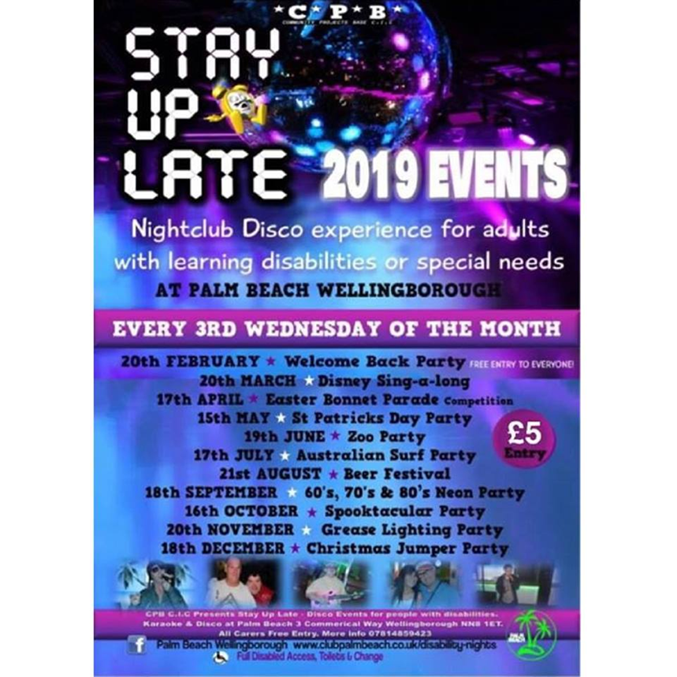

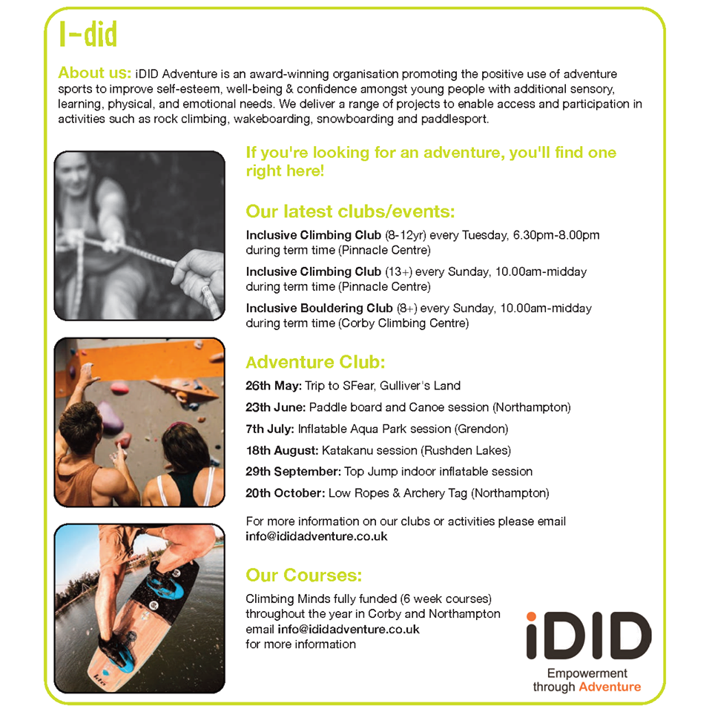

Rotary Club of Northampton West Christms Carol Concert at 2.30 pm on Sunday 8th December 2019 at St Benedict’s Church, NN4 9UG, off Hunsbury Hill Road

The Rotary Club of Northampton West has kindly asked members if they would like to attend their Christmas family and friends church service again. The church is wheelchair accessible. It would be helpful it they had some idea of numbers, please phone or email Michele if you think you might be attending. Seasonal refreshments are available. An enjoyable afternoon for all 😊

Please fill in all sections on the attached booking forms.

Food booking Quiz/Bingo night/Fish and Chips at Friday October 11th

Food needs ordering by October 4th. Food choices are:

Cod and chips £5.60 x _______
¼ chicken and chips £4.40 x _______
¼ pounder with cheese and chips £4.95 x _____
vegi burger and chips £4.40 x _______
chicken nuggets and dip £2.95 x _______
just chips for £1.65 x ______

Name:
Address:

Phone no: Email address:

Ring Caroline on 07931805999 for more information. Please make cheques payable to Cerebral Palsy Northamptonshire’
Send to: Cerebral Palsy Northamptonshire, c/o Mrs Caroline Marlow, 11 Ringway, Briar Hill, Northampton NN4 8SQ.

Classic car show at Birmingham NEC on November 9th or 10th

9th or 10th? ________ Do you have DLA/PIP proof: yes/no?

I would like to book ____ disabled and carer spaces at £10 for both

I would like to book ___ additional adult tickets at £27.50each.

I would like to book ___ additional child tickets at £17.50 each.

I would like to book ___ Under 5’s tickets (free)

Name:
Address:
Phone no: Email address:

Please make cheques payable to Cerebral Palsy Northamptonshire’
Send to: Cerebral Palsy Northamptonshire, c/o
Mrs Michele Walden, 36 Wickery Dene, Wootton Fields, Northampton, NN4 6BE.

Whilton Locks Ice Skating on Sunday November 17th at 3pm
Contact Michele to reserve a place.

I would like to book ____ disabled and carer tickets at £4 for both.
I would like to book ____ additional spaces at £7.50 children/£9 adult each.

Name:
Address:
Phone no: Email address:

Please make cheques payable to ‘Cerebral Palsy Northamptonshire’
Send to: Cerebral Palsy Northamptonshire, c/o
Mrs Michele Walden, 36 Wickery Dene, Wootton Fields, Northampton, NN4 6BE.

POTZ Ceramic Studio at Billing Garden Village on Saturday February 15th at 2pm. Contact Michele to reserve a place.

I would like to book ____ disabled and carer places at £5 for both.
I would like to book ____ additional spaces at £14 each.

Name:
Address:
Phone no: Email address:

Please make cheques payable to ‘Cerebral Palsy Northamptonshire’
Send to: Cerebral Palsy Northamptonshire, c/o
Mrs Michele Walden, 36 Wickery Dene, Wootton Fields, Northampton, NN4 6BE.

Everyone talking about Jamie at Derngate Theatre, Saturday 14th March at 2.30pm and 7.30pm. Booking closes October 10th.

Disabled and carer spaces are £10 for both. Additional tickets at 2.30pm are £35 and at 7.30pm are £42.50. Ring Michele on 07443 562739 to reserve your tickets and then please send completed booking form.

I would like to book ____ disabled and carer spaces at £10 for both. Wheelchair spaces Yes/No

Additional tickets at 2.30pm _____ at £35 each.

Additional tickets at 7.30pm _____ at £42.50 each.

Name:
Address:
Phone no: Email address:

Please make cheques payable to ‘Cerebral Palsy Northamptonshire’
Send to: Cerebral Palsy Northamptonshire, c/o
Mrs Michele Walden, 36 Wickery Dene, Wootton Fields, Northampton, NN4 6BE.

Aladdin at Milton Keynes Theatre on Saturday 14th December at 2.30pm, Sunday 5th January at 2pm and 8th January at 1pm (relaxed performance.

Saturday 14th December at 2.30pm or 5th January at 2pm or 8th January at 1pm (relaxed performance). (Please circle)

For this trip please ring Janet on 948151to reserve a place.

I would like to book ____ disabled and carer spaces at £10 for both. Wheelchair spaces Yes/No

Additional tickets on Saturday 14th _____ at £15.75 each.

Additional tickets on Sunday 5th January _____ at £15.75 each.

Additional tickets on Wednesday 8th January _____ at £14.75 each.

Name:
Address:
Phone no: Email address:

Please make cheques payable to ‘Cerebral Palsy Northamptonshire’. If you would like to receive confirmation of your booking, please send a SAE. Send to: Cerebral Palsy Northamptonshire,
c/o Janet Shrewsbury, 36 Winchester Road, Delapre, Northampton, NN4 8AY.

